Phylogenetic Comparative Methods in R

Part I: Using phylogeny as a statistical fix

Aims
To learn how to use R to answer phylogenetic comparative questions (without panicking!). By the end of this problem set you should be able to:
- Read in your data and phylogeny
- Match taxa in your phylogeny with those in your dataset
- View and manipulate your phylogeny
- Perform independent contrasts analyses using ape and/or caper
- Calculate measures of phylogenetic signal (λ and K) using geiger and/or picante
- Perform PGLS analyses using ape and nlme and/or caper
- Perform a phylogenetic ANOVA using geiger

We will be using the evolution of primate life-history variables as an example, these data come from the PanTHERIA database (Jones et al. 2009) and 10kTrees.

Outline

Preparations
1) Setting the working directory
2) Installing packages
3) Loading the packages in R
4) Loading the data
5) Loading a phylogeny
6) Manipulating your tree and data
        - Species names with spaces.
        - Species in the tree but not in the dataset.
        - Species in the dataset but not in the tree.
        - Species names = row names
        - Missing data entries

Controlling for phylogeny
1) Ordinary least squares (OLS) regression

2) Controlling for phylogeny I: Independent contrasts
        - Independent contrasts with ape
        - Independent contrasts with caper
3) Phylogenetic signal
        - Phylogenetic signal I: Pagel’s λ (lambda)
        - Phylogenetic signal II: Blomberg’s K
4) Controlling for phylogeny II: Phylogenetic generalised least squares
        - PGLS I: ape and nlme
        - PGLS II: caper
5) Controlling for phylogeny III: Phylogenetic ANOVA

Additional help
1) Removing missing data
2) Model diagnostic plots in caper
3) Outliers in crunch models

Preparations

1) Setting the working directory
First you need to download all the files for this problem set into a folder somewhere on your computer, let’s call it “R_Analyses_2011”. We will use this folder throughout the two problem sets. After opening R on your computer, you need to change the working directory in R to the “R_Analyses_2011” folder so that R knows where to look for and write files. Do this by typing into the command prompt the file path of the folder. For example:

setwd("C:/Users/Natalie/Desktop/R_Analyses_2011")

Note that R doesn't like \ so you need to change any \ in the pathway to / or \\

Next, open a text editor. WordPad or Notepad are perfect. You can type (or copy and paste) your code into the text editor, edit it until you think it'll work, and then paste it into R's console window. Saving the text file lets you keep a record of the code you used, which can be a great timesaver if you want to use it again. In this problem set, you'll largely be cutting and pasting. This handout contains pretty much all the R code you need. However, it also sometimes includes the prompts (>) and continuation signs (+). You don't want to paste these into R, so edit them out in your text editor. If you want to add comments to the file (i.e., notes to remind yourself what the code is doing), put a hash/pound sign (#) in front of the comment.

#Comments are ignored by R but can remind you what the code is
#doing.
#You need a hash sign at the start of each line of comment.

2) Installing packages
To run comparative analyses in R, you need to download one or more additional packages from the basic R installation. Mac users can download packages via the Package Installer in the Packages & Data menu. PC users can download packages by selecting install packages from the Packages menu. You will need to install the following packages: ape, geiger, nlme, picante and caper. Packages can also be downloaded by using the command line. For example, to install the package ‘ape’, type:

install.packages("ape")

3) Loading the packages in R
Make sure all the packages are loaded in your current session of R. This doesn't happen automatically so you need to do this every time you start a new R session and want to use functions from these packages. For example, to load the package ape into your current R session, type into R:

library(ape)

4) Loading the data
You now need to load the data we are going to use for the analysis. R can read files in lots of formats, including comma-delimited and tab-delimited files. Excel (and many other applications) can output files in this format (it's an option in the Save As dialogue box under the File menu). We have given you a tab-delimited text file called "Primatedata.txt" which we are going to use. Load these data as follows:

primatedata <- read.table("Primatedata.txt", sep = "\t", header = TRUE)

Note that sep = "\t" indicates that you have a tab-delimited file, sep = “,” would indicate a comma-delimited csv file. You can also use read.delim for tab delimited files or read.csv for comma delimited files. header = TRUE, indicates that the first line of the data contains column headings.

We can look at the data by typing:

primatedata
str(primatedata)
head(primatedata)
names(primatedata)

str shows the structure of the data frame (this can be a useful command when you have a big data file). It also tells you what kind of variables R thinks you have (characters, integers, numeric, factors etc.). head gives you the first few rows of data, and names gives you the names of the columns.

As you can see, the data contains the following variables: Order, Family, Binomial, AdultBodyMass_g, GestationLen_d, HomeRange_km2, MaxLongevity_m, and SocialGroupSize.

5) Loading a phylogeny
To load a tree you need either the function read.tree or read.nexus. read.tree can deal with a number of different types of data (including DNA) whereas read.nexus reads NEXUS files. We will use a NEXUS file of the consensus tree from 10kTrees (see Charlie’s talk later in the workshop).

primatetree <- read.nexus("consensusTree_10kTrees_Version2.nex")

Let’s examine the tree by typing:

primatetree
str(primatetree)

primatetree is a fully resolved tree with branch lengths. There are 226 species and 221 internal nodes. We can plot the tree by using the plot function of ape:

plot(primatetree)

Note that the tree is too large to read. You can make the node labels smaller, but that doesn’t help much here:

plot(primatetree, cex = 0.5)

Alternatively you can zoom into different sections of the tree which you’re interested in:

zoom(primatetree, list(grep("Cercopithecus", primatetree$tip.label)), subtree = FALSE)#just gives you the tree for Cercopithecus species

zoom(primatetree, list(grep("Cercopithecus", primatetree$tip.label)), subtree = TRUE)#just gives you the tree for Cercopithecus species but
#also shows you how it fits into the rest of the tree.

6) Manipulating your tree and data
Often you will have data for species which are not in your tree, or species in your tree which are not in your dataset, or species with NAs for some variables. Some functions in R can deal with this, others will refuse to work. So it's useful to know how to deal with these problems.

NOTE: the caper function comparative.data does all this matching up for you! ☺ So you don’t need to worry about matching the tree to the data etc. Ape does need this matching generally. It’s also generally useful to know how to manipulate your data.

First we can use a function from geiger to see if the species names in the data frame match those in the phylogeny:

name.check(primatetree, primatedata, data.names = primatedata$Binomial)

Oh no! Our species names don’t seem to match up! What’s the problem and how can we fix it?

Species names with spaces. Species names in the tree cannot contain spaces so they are commonly written as Genus_species (the gap between the genus name and species name replaced by _). If the species names in the data table do contain spaces then you will have to remove them so that they match up with the tree. You can do this as follows:

primatedata$Binomial <-gsub(" ", "_", primatedata$Binomial)

gsub = general substitution. It replaces any instance of the first thing (here it’s a space) with the second thing (_) but only in the variable you tell it to (primatedata$Binomial).

Repeat the name.check. You can see it looks better than before but there are a lot of mismatches.

Species in the tree but not in the dataset. These are easy to remove using the ape function drop.tip:

primatetree2 <-drop.tip(primatetree, "Aotus_azarae_infulatus")
str(primatetree2)#notice that you now have only 225 tips

For some reason it is not possible to select species from a tree. Therefore you need to list the species which you do NOT want to select and then drop them from the tree instead. This is also fairly straightforward using the R command match.

matches<-match(primatetree$tip.label,primatedata$Binomial, nomatch=0)

This command gives each species in the tree a value of 0 if it doesn't also appear in the dataset and a value >0 if it does appear in both.

not<-subset(primatetree$tip.label, matches ==0)

This subsets out the species from the tree with are NOT in the dataset (i.e., the species we want to drop). Note in R == means equals, and != means does not equal. We now have a list of species we want to drop so we use drop.tip to get rid of them.

primatetree2 <-drop.tip(primatetree, not)

You should check drop.tip is working as expected by plotting the tree:

plot(primatetree2)

Species in the dataset but not in the tree. To remove species from the dataset which are not in the tree you can also use match:

matches2 <- match(primatedata$Binomial, primatetree2$tip.label, nomatch = 0)

primatedata2 <-subset(primatedata, matches2 !=0)

Remember != means “does not equal”. So this line of code only selects species which do appear in the tree, i.e. their value from matches2 is not 0. Again you should check this has worked by looking at the dataset and the phylogeny and doing a final name check:
str(primatedata2)
str(primatetree2)

name.check(primatetree2, primatedata2, data.names = primatedata2$Binomial)

Species names = row names. A number of functions require that species names are the rownames of the data. This is really easy to fix:

row.names(primatedata2)<-primatedata2$Binomial

Missing data entries. Missing data can be a big problem in R. To make things easier we have removed species with missing data for this problem set. However, see the code at the end of this problem set if you need to do this.

Controlling for phylogeny

1) Ordinary least squares (OLS) regression
Let’s assume that we’re interested in the relationship between primate body mass and gestation length. First we should look at the data:

par(mfrow = c(2,2))

hist(primatedata2$AdultBodyMass_g)
hist(primatedata2$GestationLen_d)
#these are quite skewed so we probably want to log transform them:
hist(log(primatedata2$AdultBodyMass_g))
hist(log(primatedata2$GestationLen_d))

Let’s make two new variables, the log transforms of AdultBodyMass_g and GestationLen_d:

primatedata2$lnAdultBodyMass_g <- log(primatedata2$AdultBodyMass_g)
primatedata2$lnGestationLen_d <- log(primatedata2$GestationLen_d)

We could perform a non-phylogenetic regression just for fun. lm = linear model.

par(mfrow = c(1,1))

model.ols<- lm(lnGestationLen_d~ lnAdultBodyMass_g, data = primatedata2)
summary(model.ols)

The output should look like this:

Call:
lm(formula = lnGestationLen_d ~ lnAdultBodyMass_g, data = primatedata2)

Residuals:
Min 1Q Median 3Q Max
-0.616139 -0.082793 0.006455 0.114143 0.505577

Coefficients:
Estimate Std. Error t value Pr(>|t|)
(Intercept) 4.1037 0.1108 37.042 < 2e-16 ***
lnAdultBodyMass_g 0.1204 0.0141 8.544 1.10e-12 ***
---

Signif. codes: 0 ‘***’ 0.001 ‘**’ 0.01 ‘*’ 0.05 ‘.’ 0.1 ‘ ’ 1

Residual standard error: 0.1977 on 75 degrees of freedom
Multiple R-squared: 0.4933, Adjusted R-squared: 0.4865
F-statistic: 73.01 on 1 and 75 DF, p-value: 1.097e-12

The slope is positive (0.1204±0.0141), and very significant (note that R can’t give values lower than <2e-16 which is why it shows up so often).We can also plot the regression line on a scatter plot:

plot(lnGestationLen_d ~ lnAdultBodyMass_g, data = primatedata2)
abline(model.ols)

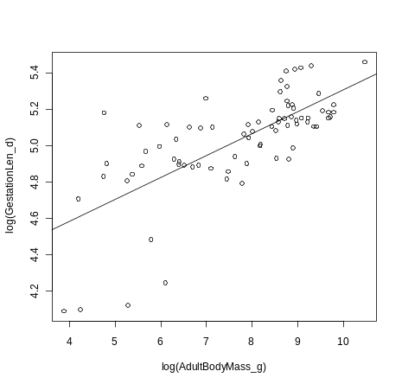

We can look at the pseudoreplication problem on the graph by looking at just one family.

points(lnGestationLen_d[Family == "Cercopithecidae"]~ lnAdultBodyMass_g[Family == "Cercopithecidae"], data = primatedata2, col= "blue", pch = 16)

2) Controlling for phylogeny I: Independent contrasts

Note that many things in R can be done in multiple ways. You should choose the methods you feel most comfortable with, and don’t panic if someone is doing the same analyses as you in a different way!

We can do independent contrasts analyses in two ways, with ape or with caper.

Independent contrasts with ape

First you need to take the contrasts themselves using the ape function pic. You then use the standard lm function to fit the model. Remember that for contrasts you must force the regression through the origin. The “-1” at the end of the model formula is how you do this:

lnGest<-(primatedata2$lnGestationLen_d)
names(lnGest)<-primatedata2$Binomial

lnBM<-(primatedata2$lnAdultBodyMass_g)
names(lnBM)<-primatedata2$Binomial

contr.logGest<-pic(lnGest, phy = primatetree2)
contr.logBM<-pic(lnBM, phy = primatetree2)

model.ic1<-lm(contr.logGest ~ contr.logBM -1)
summary(model.ic1)

The slope is positive and significant (p < 0.001). Again we can plot the regression line on a scatter plot. Note that the points are now the contrasts, not the species values.

plot(contr.logGest ~ contr.logBM)
abline(model.ic1)

Independent contrasts with caper

caper calculates contrasts and fits the model in one step. However, you first need to combine the phylogeny and data into one object:

primate <- comparative.data(phy = primatetree2, data = primatedata2, names.col = Binomial, vcv = TRUE, na.omit = FALSE, warn.dropped = TRUE)

NOTE: vcv = TRUE stores a variance covariance matrix of your tree. You will need this for pgls later. na.omit = FALSE stops the function from removing species without data for certain variables. warn.dropped = TRUE will show you any species which are not in the tree and the dataset and are therefore dropped from the data object. Make sure you check this list is what you expected, it may reveal typos in your species names. If you want to turn this off use warn.dropped = FALSE. This function does all the matching of data and tree for you. We did it above but why not check that it works using primatedata and primatetree (rather than our matched up primatedata2 and primatetree2).

We then use the function crunch to fit the model:

model.ic2 <- crunch(lnGestationLen_d~ lnAdultBodyMass_g, data = primate)
summary(model.ic2)

The output should look like this:

Call:
lm(lnGestationLen_d ~ lnAdultBodyMass_g - 1, data = contrData)

Residuals:
Min 1Q Median 3Q Max
-0.057175 -0.019023 -0.004404 0.011271 0.219140

Coefficients:
Estimate Std. Error t value Pr(>|t|)
lnAdultBodyMass_g 0.10118 0.02482 4.076 0.000113 ***
---

Signif. codes: 0 ‘***’ 0.001 ‘**’ 0.01 ‘*’ 0.05 ‘.’ 0.1 ‘ ’ 1

Residual standard error: 0.03687 on 75 degrees of freedom
Multiple R-squared: 0.1813, Adjusted R-squared: 0.1704
F-statistic: 16.61 on 1 and 75 DF, p-value: 0.0001128

We can plot the contrasts as follows:

primatecontrasts <- caic.table(model.ic2)
plot(primatecontrasts[,1] ~ primatecontrasts[,2])
abline(model.ic2)

3) Phylogenetic signal

Phylogenetic signal I: Pagel’s λ (lambda)

To compute lambda we use the fitDiscrete or fitContinuous functions of geiger, depending on whether your data is discrete or continuous.

To generate the maximum likelihood estimate of lambda for log GestationLen_d:

lambda_GL_ML<-fitContinuous(phy = primatetree2, data = primatedata2$lnGestationLen_d, data.names = primatedata2$Binomial, model = "lambda")

We can look at the output by typing lambda_GL_ML. The output should look like this:

> lambda_GL_ML
$Trait1
$Trait1$lnl
[1] 34.92036
$Trait1$beta
[1] 0.001101004
$Trait1$lambda
[1] 0.9483143
$Trait1$aic
[1] -63.84072
$Trait1$aicc
[1] -63.50738
$Trait1$k
[1] 3

lnl = log likelihood, beta = Brownian rate parameter, lambda = Pagel's lambda, aic = Akaike Information Criterion, aicc = corrected AIC, k = number of parameters in the model.

We’re interested in whether the value of lambda is significantly different from 0 (no phylogenetic signal) and 1 (trait distribution matches a Brownian model of evolution).
In this case it’s fairly obvious that lambda is almost 1. However, we should test this statistically using likelihood ratio tests.

First we need to get the log likelihood (lnl) if lambda = 0 and if lambda = 1. We can do this by transforming our tree using the geiger function lambdaTree to get two phylogenies, one where lambda = 0 and one where lambda =1. We then estimate lambda for log GestationLen_d on each tree and compare log likelihoods using likelihood ratio tests.

primatetree_L0<- lambdaTree(primatetree2, lambda = 0)
plot(primatetree_L0)#note this is now a star phylogeny

We can then generate the log likelihoods for this tree and the original tree where lambda = 1:

lambda_GL_L0<- fitContinuous(phy = primatetree_L0, data = primatedata2$lnGestationLen_d, data.names = primatedata2$Binomial, model = "BM")

lambda_GL_L1<- fitContinuous(phy = primatetree2, data = primatedata2$lnGestationLen_d, data.names = primatedata2$Binomial, model = "BM")

We can then put these numbers into the log likelihood ratio formula:

LR = -2*log-likelihood_{null} – likelihood_{alternative}

For example, to compare the log likelihood ratio where lambda is 0 to where it is allowed to take its maximum value:

LLR0 <- -2*(lambda_GL_L0$Trait1$lnl - lambda_GL_ML$Trait1$lnl)

LLR0

Or compare the log likelihood ratio of where lambda is 1 to where it is allowed to take its maximum value:

LLR1 <- -2*(lambda_GL_L1$Trait1$lnl - lambda_GL_ML$Trait1$lnl)

LLR1

Then you can get a p-value from the χ² squared distribution:

pchisq(LLR0, df=1, lower.tail = FALSE)

pchisq(LLR1, df=1, lower.tail = FALSE)

So as we expected, our ML estimate of lambda is significantly greater than 0 and not significantly different from 1.

Phylogenetic signal II: Blomberg’s K

To calculate Blomberg’s K we use the Kcalc function in picante. First set up a new vector with the values for the variable you are interested in (lnGestationLen_d) and with the names of your species:

lngest<-primatedata2$lnGestationLen_d
names(lngest)<-primatedata2$Binomial

Then calculate K for this variable:

Kcalc(lngest[primatetree2$tip.label], primatetree2)
Note that Kcalc (and phylosignal) require the trait data to be in the same order as the tree tip labels. lngest[primatetree2$tip.label] selects gestation lengths from the species in the same order as they are in the tree (square brackets [ ] are used in R to subset a dataset).

K for log gestation length is 0.776. As with the lambda calculation above, we’re interested in whether the value of K is significantly different from what we’d expect by chance. We can do this using the function phylosignal.This function randomly assigns the trait values to the species and then calculates K. This is repeated 1000 times (if reps = 1000) and the observed value of K is then compared to the randomised values to determine its significance.

phylosignal(lngest[primatetree2$tip.label], primatetree2, reps = 1000)

The output looks like this:

K PIC.variance.obs PIC.variance.rnd.mean

1 0.7757771 0.001660764 0.01214137
PIC.variance.P PIC.variance.Z
1 0.000999001 -2.244594

In this case the observed K is significantly higher than the random values of K (Z = -2.245, p < 0.001, mean of the random values = 0.012).

4) Controlling for phylogeny II: Phylogenetic generalised linear models (PGLS)

Phylogenetic generalized least squares (PGLS) models offer some important advantages over independent contrasts. The model of trait evolution can be more flexible i.e., it can depart from a strict Brownian motion process (lambda or K = 1). Different scaling parameters (lambda, kappa, and delta) can be incorporated in the analysis (see PGLS in caper below for kappa and delta methods), which can significantly improve the fit of the data to the model and thus also improve the estimation of the trait correlation. Another advantage of PGLS is that the intercept of the regression is not forced to be zero.
Again there are two ways to do this, with ape and with caper.

PGLS I: ape and nlme

Fitting a PGLS model using ape begins with setting the error structure for the regression. The ape package has several different phylogenetic error structures that are each constructed with different functions. Here we use the corPagel function that optimizes the parameter lambda. You can either set lambda to be a certain number, or allow the function to find the maximum likelihood value of lambda.

cor_lambda1<-corPagel(value=1,phy=primatetree2,fixed=TRUE) #lambda=1
cor_lambda0<-corPagel(value=0,phy=primatetree2,fixed=TRUE) #lambda=0
cor_lambdaML<-corPagel(value=1,phy=primatetree2,fixed=FALSE) #estimates ML value of lambda

The "fixed=FALSE" part indicates that we are NOT fixing lambda at 1. Instead the gls function (see below) will find the maximum likelihood estimate of lambda at the same time as fitting the model.
We can then fit a GLS model using the function gls from the package nlme. cor_lambdaML is the correlation structure for our error term in this GLS model.

model.pgls1 <- gls(lnGestationLen_d~ lnAdultBodyMass_g, correlation = cor_lambdaML, data = primatedata2)

summary(model.pgls1)

The output should look like this:

Generalized least squares fit by REML
Model: lnGestationLen_d ~ lnAdultBodyMass_g

Data: primatedata2
AIC BIC logLik
-75.78032 -66.51037 41.89016

Correlation Structure: corPagel
Formula: ~1
Parameter estimate(s):
lambda
0.8997639

Coefficients:
Value Std.Error t-value p-value
(Intercept) 4.292304 0.16203122 26.490601 0
lnAdultBodyMass_g 0.104646 0.01978655 5.288764 0

Correlation:
(Intr)
lnAdultBodyMass_g -0.828

Standardized residuals:
Min Q1 Med Q3 Max
-3.2099648 -0.6220457 -0.2488976 0.2079305 1.7447490

Residual standard error: 0.2247076
Degrees of freedom: 77 total; 75 residual

There is a significant positive correlation between log gestation length and log body mass (slope = 0.104646, p <0.0001), and lambda = 0.8998.

Note that you should always check what lambda has been used because sometimes you get strange values! Firstly corPagel can produce negative lambdas. These may be meaningful statistically but have are debatable meaning or value in evolutionary models because they imply negative branch lengths. We recommend using caper or BayesTraits (see later in the workshop) if ape estimates lambda to be below zero. Secondly ape can also produce lambdas greater than 1, which caper does not do. This is theoretically possible but be wary as these values are sometimes impossibly large (again implying negative branch lengths). Note that in Pagel’s most recent writings he said lambda should be bounded at zero (ape doesn’t do this) and at a number above 1 that is determined by the phylogeny (ape applies no bound, caper bounds at 1).

PGLS II: caper

caper requires you to first combine the phylogeny and data into one object:

primate <- comparative.data(phy = primatetree2, data = primatedata2, names.col = Binomial, vcv = TRUE, na.omit = FALSE, warn.dropped = TRUE)

The function for PGLS analyses in caper is pgls. To fit a model which uses the maximum likelihood estimate of lambda we use the following code:

model.pgls2<-pgls(lnGestationLen_d~ lnAdultBodyMass_g, data = primate, lambda='ML')
summary(model.pgls2)

The output should look like this:

Call:
pgls(formula = lnGestationLen_d ~ lnAdultBodyMass_g, data = primate,
lambda = "ML")

Residuals:
Min 1Q Median 3Q Max
-0.098899 -0.011661 0.003082 0.017758 0.075133

Branch length transformations:

kappa [Fix] : 1.000
lambda [ ML] : 0.892
lower bound : 0.000, p = 1.1435e-14
upper bound : 1.000, p = 0.00046393
95.0% CI : (0.753, 0.967)
delta [Fix] : 1.000

Coefficients:
Estimate Std. Error t value Pr(>|t|)
(Intercept) 4.290229 0.160355 26.7546 < 2.2e-16 ***
lnAdultBodyMass_g 0.104864 0.019628 5.3426 9.48e-07 ***
---

Signif. codes: 0 ‘***’ 0.001 ‘**’ 0.01 ‘*’ 0.05 ‘.’ 0.1 ‘ ’ 1

Residual standard error: 0.0261 on 75 degrees of freedom
Multiple R-squared: 0.2757, Adjusted R-squared: 0.266
F-statistic: 28.54 on 2 and 75 DF, p-value: 6.062e-10

As well as the standard regression outputs, the output includes the estimated ML value of lambda (0.892) and p values from likelihood ratio tests showing whether the ML lambda is significantly different from 0 or 1. Kappa and delta are also tree transformations which can improve the fit of the data to the tree. It is also possible to use pgls to optimise kappa or delta (using delta = "ML" or kappa = "ML" instead of lambda = "ML" in the code above). We will not cover this today but please ask if you want to know more. Note that optimising more than one of these parameters at the same time is not advisable because it would be nearly impossible to interpret the results!

We can also plot the results:

plot(lnGestationLen_d~ lnAdultBodyMass_g, data = primatedata2)
abline(model.pgls2)

See “Additional help” section below for information on model diagnostics and the removal of outliers.

5) Controlling for phylogeny III: Phylogenetic ANOVA

Regression models are not the only statistics which suffer from the phylogenetic non-independence of data points. We don’t have time to go through everything but one quick example is the phylogenetic ANOVA.

For example if we want to find out whether the different primate families have significantly different body masses we could perform an ANOVA in R as follows:

model.aov<-aov(lnAdultBodyMass_g ~ Family, data = primatedata2)
summary(model.aov)

The output should look like this:

Df Sum Sq Mean Sq F value Pr(>F)
Family 14 165.740 11.8386 23.706 < 2.2e-16 ***
Residuals 62 30.963 0.4994
---

Signif. codes: 0 ‘***’ 0.001 ‘**’ 0.01 ‘*’ 0.05 ‘.’ 0.1 ‘ ’ 1

The different families of primates have significantly different body masses, but is this just a result of the phylogenetic pseudoreplication? We can correct the p-value using the phylogenetic anova function in geiger: phy.anova.

phy.anova(primatetree2, primatedata2$lnAdultBodyMass_g, primatedata2$Family, data.names=primatedata2$Binomial)

The output should look like this:

Standard ANOVA:
Analysis of Variance Table

Response: td$data
Df Sum Sq Mean Sq F value Pr(>F)
group 14 165.740 11.8386 23.706 < 2.2e-16 ***
Residuals 62 30.963 0.4994
---

Signif. codes: 0 ‘***’ 0.001 ‘**’ 0.01 ‘*’ 0.05 ‘.’ 0.1 ‘ ’ 1

Phylogenetic p-value: 0.000999001>

There is still a significant difference in body mass among primate families (Phylogenetic p-value < 0.05) when we take phylogeny into account.

We can also plot this result as follows:

plot(lnAdultBodyMass_g ~ Family, data = primatedata2, cex.axis = 0.5)

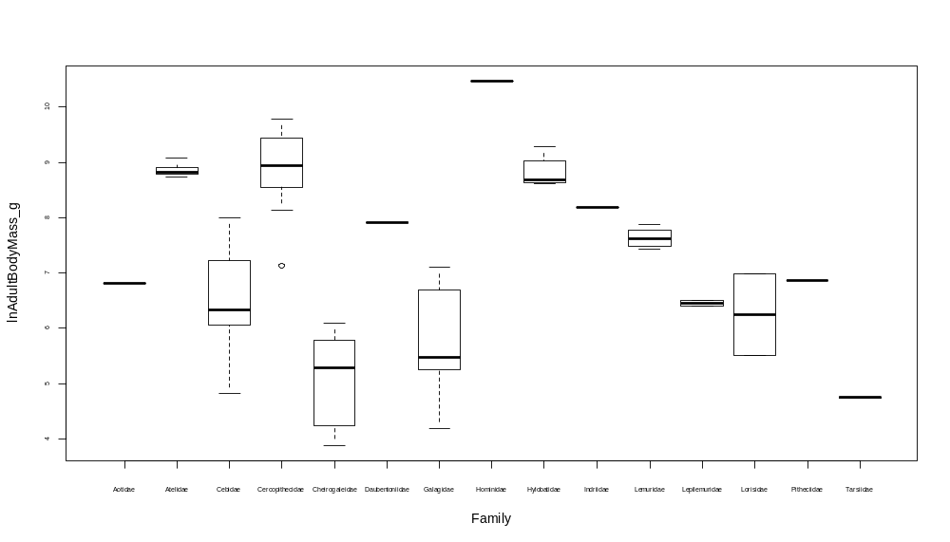

Note that in order to do these analyses, your grouping variable (here = Family) must be a factor. You can check what R thinks your variable is using str(dataset), or is.factor(variablename). To make a variable into a factor use as.factor, e.g.:

model.aov<-aov(lnAdultBodyMass_g ~ as.factor(Family), data = primatedata2)

Exercises

We have provided code to run these analyses on just a few variables. If you have time, try and run some analyses on the other variables. Here are some example questions to get you started...

1) What is lambda for primate social group size?
2) Make a plot of social group size against home range size. Colour the Cebidae in green.
3) Perform a PGLS of two variables of your choice.
4) Does home range size differ significantly among the different primate genera?
5) What is Blomberg’s K for adult body mass?
6) Plot the primate tree and zoom in on the Saimiri genus.
7) Run an independent contrasts analysis to determine the relationship between social group size and gestation length. How does this differ from the result obtained with an OLS regression? Plot the results of both analyses.

Additional help

Removing missing data

Often we don’t have data on every variable for every species. In these cases some functions (pic for example) won’t work so these need to be removed. For example, in the table below we need to remove species C to look at the relationship between body mass and group size:

Species | BodyMass | GroupSize | Habitat | Diet
A | 100 | 1 | 7 | 4
B | 150 | 5 | 7 | 6
C | 200 | NA | 8 | 5
D | 120 | 9 | 4 | 1

We do this using the function complete.cases:

complete<-complete.cases(alldata)
id<-which(complete == TRUE)
alldata2<-alldata[id,]

This will leave species A, B and D in alldata2.

The problem arises in a situation like this:
Species | BodyMass | GroupSize | Habitat | Diet
A | 100 | 1 | NA | 4
B | 150 | 5 | 7 | NA
C | 200 | NA | 8 | 5
D | 120 | 9 | 4 | 1

If we use complete.cases on the whole dataset, the only species left will be species D!, even though A and B also have the two variables we are interested in (body mass and group size). To avoid this we need to make a new dataframe and only include Species, BodyMass and GroupSize:

newdata<-data.frame(Species = alldata$Species, BodyMass = alldata$BodyMass, GroupSize = alldata$GroupSize)

complete<-complete.cases(newdata)
id<-which(complete == TRUE)
newdata2<-newdata[id,]

newdata2 will now contain species A, B and D.

Model diagnostic plots in caper

It is generally worth checking model diagnostic plots whenever you fit a model in R to check that your data meet the assumptions of linear modelling. The method for this is the same for OLS, independent contrasts and PGLS models (though the graphs are slightly different):

par(mfrow=c(2,2))#so you can see all 4 plots at once
plot(model.pgls2)
par(mfrow=c(1,1))#to reset the graphic window to just one graph

Here are the model diagnostics for our caper model above:
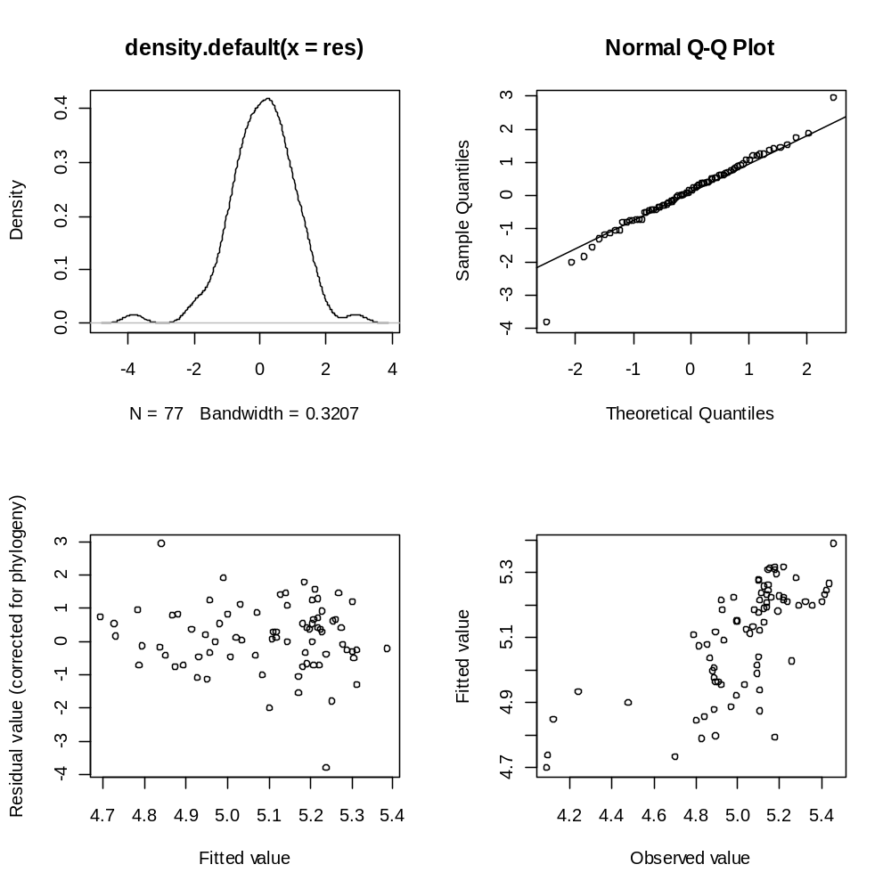

Essentially what you are looking for in these plots are:
1) No studentised model residuals >±3. Any species with such large residuals should be removed. These outliers may overly influence the results of the regression.
2) The points of the Q-Q plot should approximately form a straight line (rather than a banana shape).
3 and 4) These should show a fairly random scattering of points. You want to avoid any clear patterns.

It takes practice to know what is “good”, “bad” and “acceptable” with these plots. I would say the plots above are fine, but there appears to be an outlier which needs to be removed.

To identify the outliers in a PGLS model:

res <- residuals(model.pgls2, phylo = TRUE)
#extracts phylogenetic residuals from the pgls model

res <- res/sqrt(var(res))[1]
#standardises residuals by sqrt of their variance

rownames(res)<-rownames(model.pgls2$residuals)
#matches the residuals up with the species names

rownames(res)[(abs(res)>3)]
#gives the names of the outliers (in this case Colobus_ polykomos)

You can then remove these species from the data and tree and redo the analysis.

primate_nooutliers<-primate[-which(abs(res)>3),]

model.pgls2_nooutliers<-pglm(log(GestationLen_d)~ log(AdultBodyMass_g), data = primate_nooutliers, lambda='ML')
summary(model.pgls2_nooutliers)

plot(model.pgls2_nooutliers)
#note you may need to continue removing species until there are no more outliers

Outliers in crunch models

caper has an inbuilt option which automatically removes outliers with studentized residuals >±3.

model.ic2 <- crunch(lnGestationLen_d~ lnAdultBodyMass_g, data = primate, robust = TRUE)
summary(model.ic2)

Call:
lm(lnGestationLen_d ~ lnAdultBodyMass_g - 1, data = contrData)

Residuals:
Min 1Q Median 3Q Max
-0.0295170 -0.0114288 -0.0003569 0.0085675 0.0407896

Coefficients:
Estimate Std. Error t value Pr(>|t|)
lnAdultBodyMass_g 0.06162 0.01182 5.216 2.31e-06 ***
---

Signif. codes: 0 ‘***’ 0.001 ‘**’ 0.01 ‘*’ 0.05 ‘.’ 0.1 ‘ ’ 1

Residual standard error: 0.01587 on 61 degrees of freedom
Multiple R-squared: 0.3084, Adjusted R-squared: 0.2971
F-statistic: 27.2 on 1 and 61 DF, p-value: 2.312e-06

This will eventually be added to pglm as well, keep checking back to CRAN for the newest version of caper!
Other resources

R is not a very user-friendly application. For instance, typing help produces the program code underlying the help command, rather than anything actually helpful. To get help with the syntax of a command, like setwd for example, you can type help(setwd) or just ?setwd. If you don't know the name of the command, but have a keyword you could look for (say, \directory" in this case), you can use help.search("directory").Help files are terse and often not easy to understand.

Two of the best books for reference are both by Mick Crawley: An Introduction Using R and The R Book (huge). There is also a book about the ape library, by Emmanuel Paradis, Analysis of Phylogenetics and Evolution with R, which goes in detail through a lot of what ape can do. Note that some of this is out of date.

There is a growing amount of help through web tutorials and worked examples – check out these links in particular:

https://www.nescent.org/wg_phyloinformatics/R_Hackathon_1/HelpWiki

http://bodegaphylo.wikispot.org/Phylogenetics_and_Comparative_Methods_in_R

https://stat.ethz.ch/mailman/listinfo/r-sig-phylo

CRAN Task View page – http://cran.r-project.org/src/contrib/views - provides a useful introduction to the statistical packages applicable to various fields (find phylogenetic and comparative methods under Genetics).

Brain O’Meara’s page – http://www.brianomeara.info/allpackages3.html - useful comparison of these packages and their functions.

Liam Revell’s blog - http://phytools.blogspot.com/

